

**Western Australian Certificate of Education**

**ATAR course examination, 2019**

**Question/Answer Booklet**

12 PHYSICS

Name

**Test 5 – Atomic Physics**

|  |  |  |  |  |  |  |  |  |  |  |
| --- | --- | --- | --- | --- | --- | --- | --- | --- | --- | --- |
| Student Number: In figures |  |  |  |  |  |  |  |  |  |  |

**Mark: $\frac{}{\text{41}}$**  In words

#### Time allowed for this paper

Reading time before commencing work: five minutes

Working time for paper: fifty minutes

**Materials required/recommended for this paper**

To be provided by the supervisor

This Question/Answer Booklet

Formulae and Data Booklet

***To be provided by the candidate***

Standard items: pens, (blue/black preferred), pencils (including coloured), sharpener, correction fluid/tape, eraser, ruler, highlighters

Special items: non-programmable calculators satisfying the conditions set by the School Curriculum and Standards Authority for this course

**Important note to candidates**

No other items may be taken into the examination room. It is your responsibility to ensure that you do not have any unauthorised notes or other items of a non-personal nature in the examination room. If you have any unauthorised material with you, hand it to the supervisor before reading any further.

**Structure of this paper**

|  |  |  |  |  |  |
| --- | --- | --- | --- | --- | --- |
| Section | Number of questions available | Number of questions to be answered | Suggested working time  (minutes) | Marks available | Percentage of exam |
| Section One:  Short Answers | 5 | 5 | 15 | 11 | - |
| Section Two:  Problem-solving | 3 | 3 | 35 | 30 | 100 |
| Section Three:  Comprehension | - | - | - | - | - |
|  |  |  |  | **Total** | 100 |

**Instructions to candidates**

1. The rules for the conduct of examinations at Holy Cross College are detailed in the College Examination Policy*.* Sitting this examination implies that you agree to abide by these rules.

2. Write your answers in this Question/Answer Booklet.

3. Working or reasoning should be clearly shown when calculating or estimating answers.

4. You must be careful to confine your responses to the specific questions asked and to follow any instructions that are specific to a particular question.

5. Spare pages are included at the end of this booklet. They can be used for planning your

responses and/or as additional space if required to continue an answer.

• Planning: If you use the spare pages for planning, indicate this clearly at the top of the page.

• Continuing an answer: If you need to use the space to continue an answer, indicate in the original answer space where the answer is continued, i.e. give the page number. Fill in the number of the question(s) that you are continuing to answer at the top of the page.

6. Answers to questions involving calculations should be ***evaluated and given in decimal***

***form*.** It is suggested that you quote all answers to ***three significant figures***, with the

exception of questions for which estimates are required. Despite an incorrect final result, credit may be obtained for method and working, providing these are ***clearly and legibly set out***.

7. Questions containing the instruction "estimate" may give insufficient numerical data for their solution. Students should provide appropriate figures to enable an approximate solution to be obtained. Give final answers to a maximum of two significant figures and include appropriate units where applicable.

8. Note that when an answer is a vector quantity, it must be given with magnitude and direction.

9. In all calculations, units must be consistent throughout your working.

1.Photons of wavelength 290 nm are incident on a metal plate. The work function of the metal is 4.10 eV. Calculate the maximum kinetic energy of the emitted electrons. [3 marks]

2. Line **X** on the graphs below shows how the maximum kinetic energy of emitted photoelectrons varies with the frequency of incident radiation for a particular metal.

(a) Which graph shows the results for a metal **Y** that has a higher work function than **X**? (Circle the correct answer.) [1 mark]

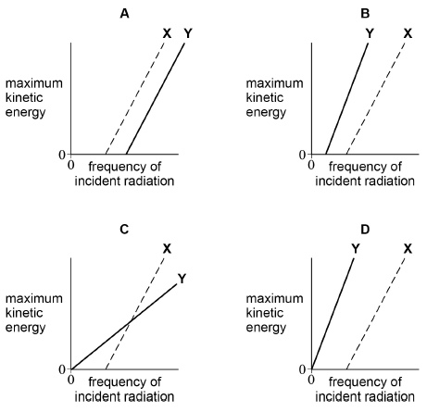

(b) Explain your choice. Include a sketch of a graph if this helps your explanation.

[2 marks]

3. A line emission and a line absorption spectrum of a particular gas were observed. Describe the differences observed between these two spectra. [3 marks]

4. Which statement suggests that electrons have wave properties?

(Circle the correct answer.) [1 mark]

(a) Electrons are emitted in photoelectric effect experiments.

(b) Electrons are released when atoms are ionised.

(c) Electrons produce dark rings in diffraction experiments.

(d) Electron transitions in atoms produce line spectra.

5. In an experiment to demonstrate the photoelectric effect, a charged metal plate is illuminated with light from different sources. The plate loses its charge when an ultraviolet light source is used but not when a red light source is used. What is the reason for this?

(Circle the correct answer.) [1 mark]

(a) The intensity of the red light is too low.

(b) The wavelength of the red light is too short.

(c) The frequency of the red light is too high.

(d) The energy of red light photons is too small.

6. (a)     Light has a dual wave-particle nature. State and outline a piece of evidence for the wave nature of light and a piece of evidence for its particle nature. For each piece of evidence, outline a characteristic feature that has been observed or measured and give a short explanation of its relevance. [6 marks]

(b)    For a proton of kinetic energy 5.00 MeV:

(i)      calculate its speed. [2 marks]

(ii)     calculate its de Broglie wavelength. [2 marks]

7. When a clean metal surface in a vacuum is irradiated with ultraviolet radiation, electrons are emitted from the metal. The following equation relates the frequency of the incident radiation to the kinetic energy of the emitted electrons.

*hf* = *ɸ* + *Ek*

(a)     Briefly statewhat each of the following terms represents in the above equation.

[3 marks]

(i)      *hf*

(ii)     *ɸ*

(iii)    *Ek*

(b) (i)      State what would happen to the number of photoelectrons ejected per second if the ultraviolet source were replaced by a source of red light of the same intensity but of frequency less than *ɸ*/*h*. [1 mark]

(ii)     What would the ***wave theory of light*** predict about the effect of using the red light source instead of an ultraviolet source? [1 mark]

(iii)    Use the ***quantum theory of light*** to explain the effect of using the red light source instead of an ultraviolet source. [3 marks]

8.

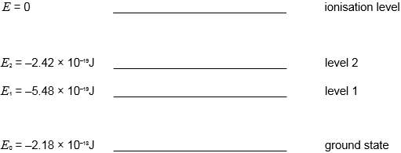

The diagram represents some of the energy levels of an isolated atom. An electron with a kinetic energy of 2.00 × 10–18 J makes an inelastic collision with an atom in the ground state.

1. Calculate the speed of the electron just before the collision. [2 marks]

(b)     (i)    Show that the bombarding electron can excite the electron in the atom to excitation level 2. [2 marks]

(ii)    Calculate the wavelength of the radiation that will result when an atom in level 2 falls to level 1 and state the region of the spectrum to which this radiation belongs. [3 marks]

(c)     Calculate the minimum potential difference through which an electron must be accelerated from rest in order to be able to ionise an atom in its ground state with the above energy level structure. [2 marks]

(d) An atom can be excited by bombardment by electrons or by bombardment by photons. Explain why, for a particular transition, the photon must have an exact amount of energy whereas the free electron only needs a minimum amount of energy.

[3 marks]